Press release  Date: 19th March 2006  Release: 06/023 | 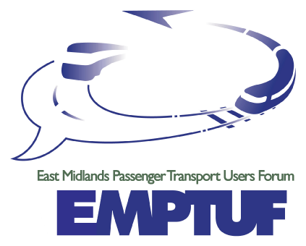
Passenger Group welcomes new Airport Bus-links,
but calls for an early start to the new Parkway Station.

EMPTUF (the East Midlands Passenger Transport Users’ Forum) today warmly welcomed the planned expansion of bus services to Nottingham East Midlands Airport (NEMA), particularly the new link to Leicester. At the same time it is pressing for an early start to the nearby East Midlands Parkway station and improved rail services across the region, when the current Central Trains and Midland Mainline franchises end in 2007.

The lack of good public transport to the airport both for air-travellers and those who work at the airport complex has long been a concern but funding had always been an issue.
Bus services to/from the Airport will now be considerably upgraded and expanded, made possible by funding from the East Midlands Development Agency (EMDA) and a government "KickStart” award. The result will be a regular and frequent round the clock buses, 7 days per week – running for 24 hours a day from Nottingham; 22 hours from Derby/Loughborough and a new 18 hour direct service from Leicester - all using dedicated low floor, quality vehicles.
EMPTUF Chairman Alan Meredith said “we welcome this major improvement in transport links between the airport and major East Midlands cities and congratulate all involved. It is an excellent example of how quality public transport is possible, given a positive partnership of operators, central and local government and critically in this case, the support of EMDA.”
EMPTUF is also pressing for an early start to the nearby East Midlands Parkway station and improved rail services across the region, when the current Central Trains and Midland Mainline franchises end in 2007. On 19th May, we will be holding a major half-day forum that will consider the impact of planned franchise changes in the way that our rail services are provided. Whilst this could be an opportunity for improved services, it could equally threaten our regional and local services, as Government seeks to reduce railway expenditure.
Organised by EMPTUF with the support of the Regional Assembly and EMDA, the event will take place on Friday 19th May, commencing at 10.30am in the Talbot Suite of the Crowne Plaza Hotel, Wollaton Street, Nottingham NG1 5RH.

For further information contact:

- Chairman, Alan Meredith on 0116 2303895
- Secretary Steve Abbott on 01858 466629
Notes for editor (overleaf)…….

Notes for editor

- EMPTUF (the East Midlands Passenger Transport Users’ Forum) is an alliance of groups representing the consumer interest across all modes of public transport. Associated organisations include RailFuture, Bus Users-UK, Transport 2000, EMTAR and many local bus and rail user groups. It has also received support from EMDA, the Regional Assembly and local authorities.

- Initially set up by the former Rail Passengers Committee for the Midlands, EMPTUF is an independent body which aims both to represent the interests and concerns of public transport passengers across all forms of transport. AND to assist local and regional authorities’ work towards an integrated and seamless quality public transport network for the East Midlands region.

- EMPTUF’s mission is to champion public transport so that it becomes:
- Accessible to everyone – including the mobility impaired
- Affordable and socially inclusive
- Available when and where needed
- Acceptable to all, whatever mode is chosen
- Attractive – with high quality of services and reliable information

4. By bringing together for the first time within a single body, representative groups of bus, rail, light rail, air and other passengers, EMPTUF offers passengers a new opportunity for strong consumer representation and to regional policy makers a route to engage with transport consumers on an integrated basis throughout the region.

For further information contact:

- Chairman, Alan Meredith on 0116 2303895

- Secretary Steve Abbott on 01858 466629

